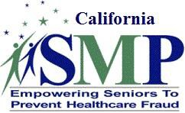

California Senior Medicare Patrol Fraud Alert - June 2020 COVID-19 Contact Tracing
California Attorney General Xavier Becerra this week warned residents to be on guard against scammers who send email, text messages or call people, pretending to be coronavirus contact tracers and trick people into providing personal information.

The scammers deceive people into believing they have come into contact with someone who has tested positive for COVID-19. Then they ask for private, healthcare information such as the Medicare number, Social Security number or bank account information.

"Legitimate contact tracers will never ask for personal information such as your Social Security number or financial information. It sickens the soul that there are people out there who make it their business to scam you as most of us seek to band together to respond to the coronavirus pandemic," Becerra said in a statement.
If you get a call such as this, please report it to Senior Medicare Patrol on our toll-free hot line 855-613-7080.

